NOVA Regional Training School
October 19-20, 2019

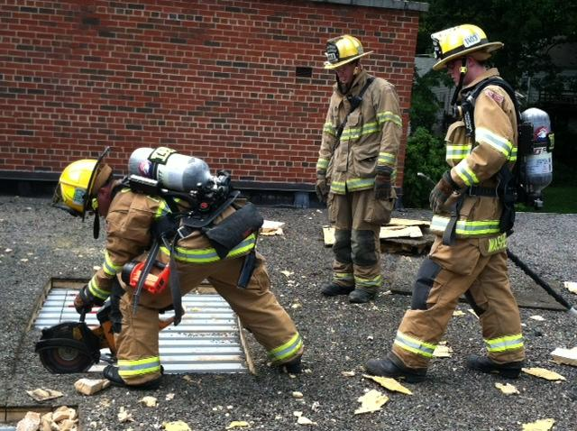

Sponsored by:

The Virginia Department of Fire Programs & NOVA Training Committee

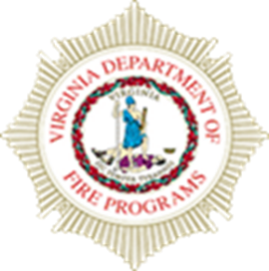

All classes will be held at the Fairfax County Fire Training Academy
4600 West Ox Road, Fairfax, Va

0800-1630
2019
NOVA Regional Training School

The Virginia Department of Fire Programs, Division 7 and the NOVA Training Officers Committee will host a NOVA Regional Training School weekend October 19-20, 2019.

Register online at VDFP (www.vafire.com) or contact the Division 7 Office

www.VAFire.com
4975 Alliance Drive
Fairfax, Virginia 22030
(703) 259-3232

Registration
Open registration begins immediately through October 18, 2019 or until classes are full.

Books
Any required texts will be sent via email attachment for student to print.

Additional Information
- Please ensure you bring to class each day, the appropriate Personal Protective Equipment (PPE) listed in your class descriptor.
- Please ensure you dress appropriately for all classes, weather could be a factor.
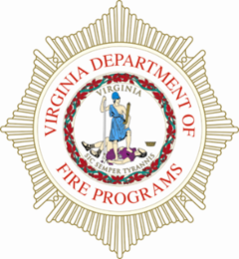
Oct 19 at 0800-1600

Live Fire Instructor Program (1403)

Curriculum: Responder Health & Safety

NFPA 1403 provides minimum requirements for conducting live fire training to ensure they are conducted in safe facilities and a safe manner for participants. This standard shall contain the minimum requirements for training all fire suppression personnel engaged in firefighting operations under live fire conditions.

This course is the update to the Live Fire Policy and NFPA 1402 Standard. All instructors that are going to be involved with live fire training should attend.

Prerequisites: IS 100, 200, 700, and 800, Instructor II, HazMat Ops

Equipment: PPE

Text Requirements: None

Hours: 8 Max. Class Size: 30

Oct 19-20, 0800-1600

F0729 - Incident Safety Officer

Curriculum: Responder Health and Safety

This two-day course examines the Safety Officer's role at emergency responses. A specific focus on operations within an Incident Command System (ICS) as a Safety Officer is a main theme. Response to all-hazards types of situations will be emphasized. This course will provide students with the knowledge and skills needed to perform the duties of the Incident Safety Officer (ISO) during incident operations and training evolutions.

Prerequisites: IS 100, 200, 700, and 800

Equipment:

Text Requirements: NFA – Incident Safety Officers Student Manual, 4th Ed. 2018

Hours: 16 Max. Class Size: 30

Oct 19-20 0800-1600

Mayday Firefighter Down

Curriculum: Firefighter Hands-On

A course designed for all members of the fire service from the Chief to the newest member. The mission of this class is to provide training for every member of the team to survive the worst event on the fireground using self-rescue techniques. The following subjects will be covered; “two-in/two-out”, self-rescue, flashover recognition, building construction for firefighter safety, firefighter accountability and other safe fireground skills.

Prerequisites: FF I, IS 100, 200, 700, and 800

Equipment: Full Running Gear

Text Requirements: Student Package

Hours: 16 Max Class Size: 24

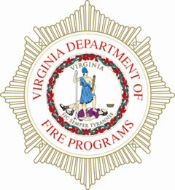
Oct 19, 0830-1230

Officer I & II TtT

Curriculum:

A course designed to cover all elements of the NFPA 1021 Officer (2014) standard. This program will introduce the Navigate 2 software to be used by the instructor and students.

Prerequisites: Fire Officer II, ICS 100, 200, 700, 800, Haz Mat Ops, Five years at Company Officer level for new instructors (Acting time, Military count as time.) Pre-Test from Jones & Bartlett Fire Officer, Principles & Practice, Enhanced 3rd Ed. with a minimum score of 75%.

Equipment: none

Text requirements: none

Hours: 4 Max Class Size: 24

Oct 19-20, 0800-1600

NFA Strategy and Tactics for Initial Company Operations
(STICO)

Curriculum:

Description: This course is designed to meet the needs of
Company Officers responsible for managing the operations of
one or more companies during structural firefighting operations.
STICO is designed to develop the management skills needed
by company officers to accomplish assigned tactics at structure
fires.

Prerequisites: IS-100, 200 and 700

Hours: 16 Max Class Size: 24

Standard/Reg: None

Student Materials: NFA-Strategies and Tactics for Company
Officers Student Manual

Oct 19-20, 0800-1600

Curriculum: Heavy Tech Rescue

Introduction to Technical Rescue, Module II

Description: Module 2 is a 16-hour introductory classroom
and practical course addressing the job performance requirements
of NFPA 1006. This course will require basic rescue skills
in the low and high angle environments to include site operations;
establishment of landing zones for helicopter operations;
victim management; rope, knots, and anchoring systems. This
course is designed for personnel who will actually serve on or
in support of a technical rescue incident. Students will receive a
VDFP Certificate of Attendance. Successful completion of Modules
1 and 2 are required prior to Module 3.

Prerequisites: HMA, 18 years of age, Introduction to Tech
Rescue Module I

Hours: 16 Max Class Size: 24

Standard/Reg: NFPA 1006, 1670

Student Materials: Introduction to Technical Rescue

Oct 19-20, 0800-1600

Curriculum: Heavy Tech Rescue

Machinery Rescue

Description: This 16 hour program includes classroom and practical training in common machinery anatomy, systemic approach to machinery rescue incidents, common machinery stabilization, incident hazard isolation, access and egress of common machinery, disentanglement of victims, the packaging and removal of victims, and operating as a member of a rescue team and directing rescue operations.

Prerequisites: 18 years of age, ITR Mod 1 & 2, VDFP Vehicle Rescue Level 1 (Operations).

Students shall be psychologically, physically, and medically capable to perform assigned duties and functions at technical search and rescue incidents and to perform training exercises in accordance with NFPA 1500 Standard on Fire Department Occupational Safety and Health Program, Chapter 10-Medical and Physical Requirements.

Equip Req: Full PPE

Hours: 16 Max Class Size: 20

